11.60: a) The center of mass of the beam is 1.0 m from the suspension point. Taking torques about the suspension point,

(note that the common factor of sin 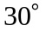 has been factored out), from which 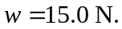

b) In this case, a common factor of sin 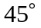 would be factored out, and the result would be the same.

